**Chapter IV**

**Results and Discussion**

**4.1 Results and Discussion**

During the testing of an actual registration where the manual and automated form has been filled up by the customer. The Proponents made an actual computation of manual registration time based in which manual registration was completed. For the purpose, the proponents timed the customer filling up the form manually.

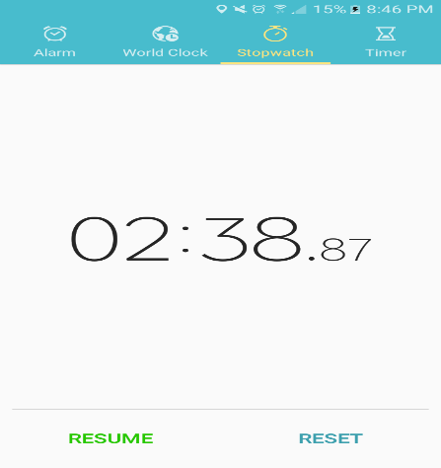

**Figure 4.1 Timed Manual Form Registration**

Figure 4.1 Timed 2 mins 38 seconds and recorded as decimal 2.38 as the average time of manual registration via forms. The proponents converted the decimal number into percentage to measure how accurate is the registration was. A=Accuracy, FR=Form Registration, CD=Convert Decimal. A=CD*100% = 238% is the accuracy of the manual form registration.

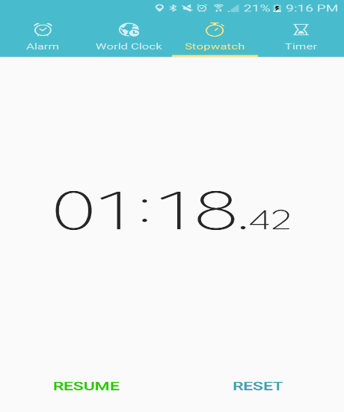

**Figure 4.2 Registration Online**

Figure 4.2 Timed at 1 mins 18 seconds recorded as decimal 1.18 as the average time of a registration online. The proponents converted the decimal number into percentage to measure the accuracy of the registration. A=Accuracy, FR=Form Registration, CD=Convert Decimal. A=CD*100% = 118% is the accuracy of the manual form registration.

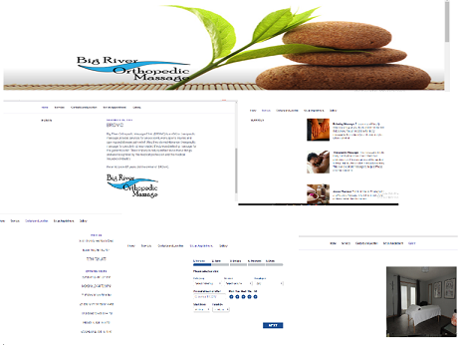

**Figure 4-1: Patient Portal User Interface**

Shown on Figure 4-1 above is the user interface of the application. This UI shows the basic interface of Patient Portal and falls under Understandability. According to ISO 9126, understandability has recognizing the logical concept and its applicability by means of its interface[ISO2000]. This refers to the attributes of the software intended to make the software more understandable to the user, such as being detailed and its simple structure.

**4.2 Test Cases**

|  |  |
| --- | --- |
| **Test no.** | **01** |
| **Test Case** | To test if the application is working |
| **Input/ Action** | User must browse the URL(www.bigriverorthopedic.com) |
| **Expected Result** | Application shows Home Page |
| **Actual Result** |  |
| **Conclusion** | Successful |
|  | |
| **Test no.** | **02** |
| **Test Case** | To test if the 1st button of navigational bar is working |
| **Input/ Action** | Click Home Link Button |
| **Expected Result** | Application shows Home Page |
| **Actual Result** |  |
| **Conclusion** | Successful |
| **Test no.** | **03** |
| **Test Case** | To test if the 2nd button of navigational bar is working |
| **Input/ Action** | Click About Link Button |
| **Expected Result** | Application shows About Page |
| **Actual Result** |  |
| **Conclusion** | Successful |
|  |  |
| **Test no.** | **04** |
| **Test Case** | To test if the 3rd button of navigational bar is working |
| **Input/ Action** | Click Contact and Location Link Button |
| **Expected Result** | Application shows Contact Page |
| **Actual Result** |  |
| **Conclusion** | Successful |

|  |  |
| --- | --- |
| **Test no.** | **05** |
| **Test Case** | To test if the 4th button of navigational bar is working |
| **Input/ Action** | Click Set Appointment Link Button |
| **Expected Result** | Application shows Appointment Page |
| **Actual Result** |  |
| **Conclusion** | Successful |
| |  |  | | --- | --- | | **Test no.** | **06** | | **Test Case** | To test if the 5th button of navigational bar is working | | **Input/ Action** | Click Gallery Link Button | | **Expected Result** | Application shows Gallery Page | | **Actual Result** |  | | **Conclusion** | Succesful | |  | | | |
| **Test no.** | **07** |
| **Test Case** | To test if drop down menu in category is working |
| **Input/ Action** | Click the arrow down button |
| **Expected Result** | Show the list of menus |
| **Actual Result** |  |
| **Conclusion** | Succesful |
| **Test no.** | **08** |
| **Test Case** | To test if drop down menu in service is working |
| **Input/Action** | Click the arrow down button |
| **Expected Result** | Show the list of menus |
| **Actual Result** |  |
| **Conclusion** | Succesful |
|  |  |
| **Test no.** | **09** |
| **Test Case** | To test if drop down menu in employees is working |
| **Input/ Action** | Click the arrow down button |
| **Expected Result** | Show the list of menus |
| **Actual Result** |  |
| **Conclusion** | Succesful |

|  |  |
| --- | --- |
| **Test no.** | **10** |
| **Test Case** | Test if the Date is working |
| **Input/ Action** | Click the date |
| **Expected Result** | Show the date |
| **Actual Result** |  |
| **Conclusion** | Succesful |
| **Test no.** | **11** |
| **Test Case** | Test if previous date is not working for setting appointment |
| **Input/ Action** | Click previous date |
| **Expected Result** | It’s not clickable (disabled) |
| **Actual Result** |  |
| **Conclusion** | Succesful |
| **Test no.** | **12** |
| **Test Case** | Test if the button can be check or uncheck for appointment |
| **Input/ Action** | Click the button you choose to check or uncheck days |
| **Expected Result** | It can be checked or unchecked |
| **Actual Result** |  |
| **Conclusion** | Succesful |
|  |
|  |
| **Test no.** | **13** |
| **Test Case** | Test if the next button is working |
| **Input/ Action** | Click the next button |
| **Expected Result** | It will proceed to the time page under set appointment page |
| **Actual Result** |  |
| **Conclusion** | Succesful |

|  |  |
| --- | --- |
| **Test no.** | **14** |
| **Test Case** | Test if the time you select is working |
| **Input/ Action** | Click the radio button and choose time you want to set an appointment |
| **Expected Result** | You can select one time only and will proceed it to detail page under set appointment page |
| **Actual Result** |  |
| **Conclusion** | Succesful |
|  | |
| **Test no.** | **15** |
| **Test Case** | Test if the back button is working |
| **Input/ Action** | Click the back button |
| **Expected Result** | It will go back to time page under set appointment page |
| **Actual Result** |  |
| **Conclusion** | Succesful |

|  |  |
| --- | --- |
| **Test no.** | **16** |
| **Test Case** | Test if you can input in the textbox |
| **Input/ Action** | Input your name |
| **Expected Result** | It will show your name in the textbox |
| **Actual Result** |  |
| **Conclusion** | Succesful |
|  | |
| **Test no.** | **17** |
| **Test Case** | Test if you can input in the textbox |
| **Input/ Action** | Input your phone number |
| **Expected Result** | It will show your phone number in the textbox |
| **Actual Result** |  |
| **Conclusion** | Succesful |
| **Test no.** | **18** |
| **Test Case** | Filling up details on the given fields |
| **Input/ Action** | Input data |
| **Expected Result** | Will proceed to the next page of payment method |
| **Actual Result** |  |
| **Conclusion** | Succesful |

|  |  |
| --- | --- |
| **Test no.** | **19** |
| **Test Case** | Test if you can input in the textbox |
| **Input/ Action** | Input your email address |
| **Expected Result** | It will show your email address in the textbox |
| **Actual Result** |  |
| **Conclusion** | Succesful |
| **20** | |
| **Test Case** | Test if you can input in the textbox |
| **Input/ Action** | Input your notes |
| **Expected Result** | It will show your notes in the textbox |
| **Actual Result** |  |
| **Conclusion** | Success |
| **Test no.** | **21** |
| **Test Case** | Test if the radio button in the payment page under set appointment is working |
| **Input/ Action** | Click the radio button |
| **Expected Result** | It was clickable |
| **Actual Result** |  |
| **Conclusion** | Succesful |

|  |  |  |  |
| --- | --- | --- | --- |
| **Test no.** | | **22** | |
| **Test Case** | | Test if you are successfully set an appointment | |
| **Input/ Action** | | Click next button in payment page under set appointment page | |
| **Expected Result** | | You already done, and it will show a message “Thank you! Your booking is complete. An email with details of your booking has been sent to you. | |
| **Actual Result** | | A screenshot of a cell phone  Description generated with very high confidence | |
| **Conclusion** | | Succesful | |
|  | | | |
| **Test no.** | | **23** | |
| **Test Case** | | Test if log in is working | |
| **Input/ Action** | | Input username and password | |
| **Expected Result** | | It will log in to the application | |
| **Actual Result** | | A screenshot of a social media post  Description generated with very high confidence | |
| **Conclusion** | | Succesful | |
| **Test no.** | **24** | |
| **Test Case** | Test if the finger print is verified | |
| **Input/ Action** | Scan your finger print in the finger print scanner | |
| **Expected Result** | Finger print verified pop up message appear. | |
| **Actual Result** |  | |
| **Conclusion** | Succesful | |

|  |  |
| --- | --- |
| **Test no.** | **25** |
| **Test Case** | Test if the update button is working in windows form |
| **Input/ Action** | Update the data |
| **Expected Result** | Update Successful pop up message will show, and the data will be updated |
| **Actual Result** |  |
| **Conclusion** | Successful |

|  |  |
| --- | --- |
| **Test no.** | **26** |
| **Test Case** | Test if delete button is working |
| **Input/ Action** | Delete an existing data |
| **Expected Result** | A pop up message will show, and ask you if you are sure to delete the data. If you click yes, the data will be deleted |
| **Actual Result** |  |
| **Conclusion** | Succesful |
|  | |
| **Test no.** | **27** |
| **Test Case** | Test if the add button is working |
| **Input/ Action** | Input data |
| **Expected Result** | The data will be added and a pop up message “adding success” will show |
| **Actual Result** |  |
| **Conclusion** | Succesful |

|  |  |
| --- | --- |
| **Test no.** | **28** |
| **Test Case** | Test if the search button is working |
| **Input/ Action** | Input name you want to search |
| **Expected Result** | It will show the information if the person you search have a record in the data base. |
| **Actual Result** |  |
| **Conclusion** | Succesful |

|  |  |
| --- | --- |
| **Test no.** | **29** |
| **Test Case** | Test if the analysis menu is working |
| **Input/ Action** | Click analysis button |
| **Expected Result** | It will show a bar graph |
| **Actual Result** |  |
| **Conclusion** | Succesful |
|  | |
| **Test no.** | **30** |
| **Test Case** | Test if adding finger print is working |
| **Input/ Action** | Scan your finger print into the scanner |
| **Expected Result** | The finger print will be captured and a pop up message “success” will show |
| **Actual Result** |  |
| **Conclusion** | Succesful |